**Simulation Paper Outline: The Evolution Of Kin Preference**

**Sept 2012 (figures at bottom of document)**

**Abstract**

Using an individual-based and genetically explicit model we explore the co-evolution of cooperation coupled with kin preference, and hence kin composition of social groups. We find that the parameter that has the largest effect on the kin composition of social groups is the fecundity of the species. Intrinsic growth rate explains close to 90% of the variance observed. The group carrying capacity only had a minor influence on the level of kin preference that evolves except if the fecundity is low, the carrying capacity very high and the cost of cooperation high. In this case high levels of cooperation did not evolve and kin preference remained low.

**Introduction**

It has long been recognized that high levels of relatedness allow the evolution of costly altruistic behaviours (refs). Therefore one might expect that, given a choice, social groups will tend to be formed with close relatives. Several factors, however, may prevent groups from being restricted to only close relatives. One scenario, for instance, involves the ecological need to form groups that are larger than the number of available relatives, either because the fecundity of a species is low (e.g., •••) or the size of the groups that need to be formed is large (e.g., •••) (Avilés et al. 2004). It may also be that locating close relatives or building up a group with a sufficiently large number of close relatives is not practical given a limited time to form groups. Additionally it may not be possible for individuals to discriminate close kin from non-relatives. The kin composition of social groups may thus be largely dictated by demographic and ecological factors, a possibility that has hardly been considered (but see Avilés et al. 2004).

Here we investigate the evolution of kin admission rules in a model where cooperative interactions cause group-living individuals to have greater fitness than individuals living solitarily or in very small groups. We consider how the kin composition of social groups evolves in response to demographic and ecological factors such as the intrinsic fecundity of a species and an externally dictated group carrying capacity. Assuming that cooperative interactions range from mutualistic to highly altruistic, we consider how kinship rules of admission evolve, influencing or being influenced by the level of cooperation that evolves within groups.

We base our model on the equation proposed by Avilés (1999) where cooperative interactions have a synergistic effect on fitness. This model has been previously used to study the coevolution between cooperative and grouping tendencies, either among nonrelatives (Avilés et al. 2002) or assuming different kinship structures (Avilés et al. 2004). While in these models group size evolves in response to the coevolution of grouping and cooperation, here we assume that group size is externally fixed by ecological factors and allow instead the evolution of the degree to which individuals discriminate against kin when becoming associated in social groups.

We find that the factor that has by far the largest effect on the kin composition of social groups is the intrinsic fecundity of a species, which explains close to 90% of the variance. Interestingly, the group carrying capacity was only a minor influence, except for a combination of very high group carrying capacity and very low fecundity, in which case groups of low relatedness formed when the relative fitness costs of cooperation were high. We also find that levels of cooperation, group size, and the kin composition of social groups oscillate through time, with cooperation and group size oscillating in parallel and being counter correlated with the degree of relatedness of the groups formed.

**Methods (Julian will write a detailed appendix of the methods if needed)**

*The model (methods copied from Julian’s documents and adapted from Veelen et al. 2010 etc.)*

In this model we assumed that individuals have the possibility to come together in groups in order to perform a task that might be done more efficiently together rather than alone. In this simulation, as in Aviles et al (2002), Aviles et al (2004) and van Veelen et al (2010), individuals come together in one-generation breeding groups. Within groups, the extent to which individuals help one another is determined by individually coded “cooperative” tendencies. Cooperation increases total group productivity, but lowers the relative fitness of cooperators within their group depending on the cost of cooperation. However this simulation departs from previous ones as the admission to groups is controlled by the strength of an individual’s genetically coded kin preference as well as the average kin preference of the group members. Both an individual’s cooperative tendencies and strength of kin preference is able to evolve.

**Per Capita Group Productivity and Relative Fitness within Groups**

We assume that the number of offspring produce per capita is maximized in groups of intermediate size as this reflects the benefits to an individual of being a group (e.g. protection from predators, greater foraging success) is balanced by the costs (e.g. crowding, resource competition)

Following (Avilés, 1999), (Avilés, 2002), (Avilés et al., 2002), (Avilés et al., 2004) and (van Veelen 2010) we therefore assume that the number of offspring produced by an individual is a function of the size of the group it is in, of the cooperativeness of the other group members within that group and of the cooperativeness of the individual itself using the function,

|  |  |
| --- | --- |
| , | (1) |

where n is the size of the group, r is the intrinsic rate of growth parameter, c is the inverse of the group carrying capacity (so the smaller c, the larger the group carrying capacity), β is the cost of cooperation, controlling the extent to which cooperative interactions are mutualistic (β=0) versus altruistic (β>0) and represents cooperative tendencies which range between 0 and 1. Therefore i is the cooperative tendency of the individual and is the average cooperative tendencies within the group.

From equation (1) it can be seen that er is the reproductive output of an individual in the absence of interactions with conspecifics, e-cn represents the negative effects of grouping on an individual’s reproductive output and represents the synergistic effects of grouping due to cooperation. is the relative fitness function, which allows for the possibility that cooperators may suffer a relative fitness cost within their groups.

**Genetic and breeding systems**

Individuals are diploid with cooperative and kinship preference each represented by 15 binary loci with 0 or 1 as possible alleles. These translate additively to phenotypic values between 0.0 and 1.0, which is the proportion of 1’s in a diploid complement. Haploid gametes are procured through processes mimicking meiosis and recombination. Mutation occurs at a rate of 10-2 per locus per generation. It is implemented through an inversion/translocation mechanism to avoid bias against the most common allele that occurs by simply mutating randomly chosen sites to the opposite allele.

For simplicity, we model a single sex, with individuals performing the female function but also able to contribute sperm. Because individuals choose mates at random from the global population prior to group formation, selfing is avoided and the system is equivalent to a two-sex system in which males are only able to fertilize eggs. This model therefore replicates species with outbreed breeding systems, such as those where males move between groups or where mating takes place before the group formation phase. However this model is not appropriate for organisms characterised by inbred social groups such as naked mole rats (Faulkes et al. 1997; Burland et al. 2002) or social spiders (Aviles 1997). To facilitate relatedness calculations, all offspring in a clutch are sired by the same father.

**Group Formation**

Groups are formed by accretion. The group formation phase involves individual leaving the global pool and one at a time at random. Each individual starts by trying to get into the last non-empty group and continues backwards from there. Because newly dispersed relatives occupy the most recently formed groups, this creates a linearly viscous population structure that maximizes encounters between relatives. If an individual is unable to join any of the groups it establishes a new one. We assume that there are ecological limits on the size of the global population by having only a limited number of available nesting sites. Individuals that do not get admitted to any of the nesting sites are discarded. Note that since individuals are chosen at random to join groups, this procedure does not bias selection.

The probability that a new member is accepted into a group is

|  |  |
| --- | --- |
|  | (2) |

Function h(j) is a group size dependent admission probability which equals 1 if the group *j* is below the optimal group size , zero if the size of j is above the expected stable group size, and linearly decreasing in between. This ensures that the group size does not explode, and is able to raise slightly above the optimal group size, as is often observed in natural populations (ref see Giraldeau 1988).

Function k weights the kinship preferences of the joiner and existing group members,

|  |  |
| --- | --- |
|  | (3) |

where Rij is the relatedness of individual i to j, m is the kinship preference with being the average kinship preference within group j and being the kinship preference of individual i. Relatedness is computed by keeping track of pedigree relationships for every individual up to the great grandmother generation, a task that is facilitated by the fact that all offspring within one clutch have the same father.

For *m* =0 relatedness does not play a role, that is, individuals have no preference for kin interactions. For *m* equal to 1 only full sibs are admitted. For *m* = 0:5 we get a linear function that approximates the kin-preference case, always letting in brothers and letting in cousins with a probability close to 1/4, second cousins with probability 1/16 and so on (figure w).

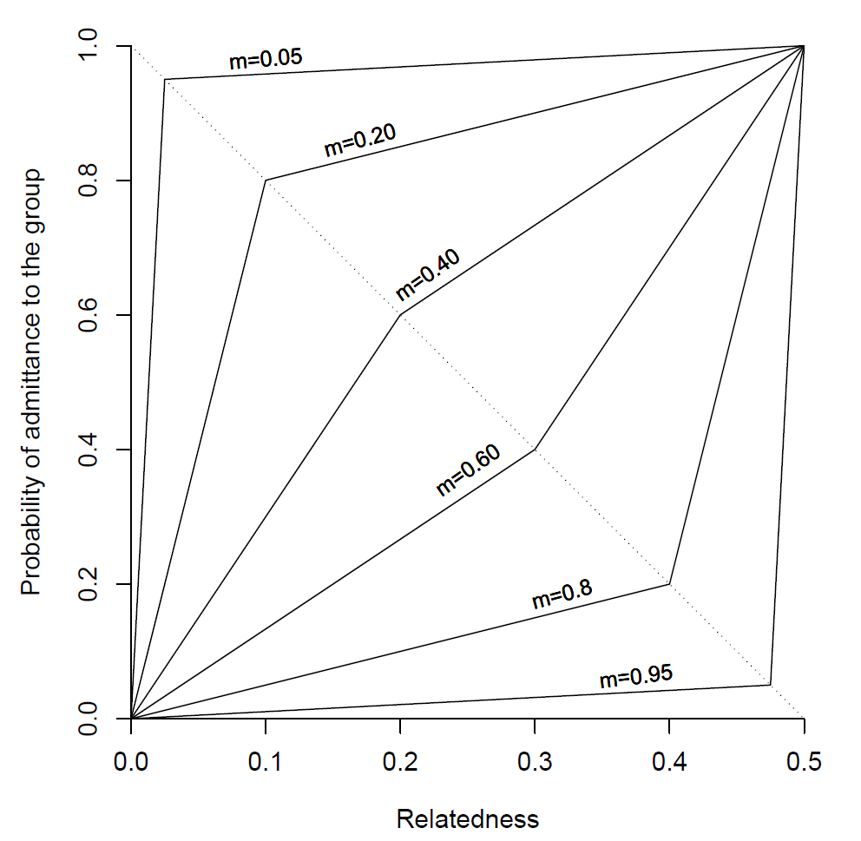

Figure w: Kinship weighting function with different values of kinship preference, m

**The simulations and Analyses**

*(Statistical description of method closely based on AmNat 2001 paper)*

The model was run for each combination of parameters values (table y) once for 50000 generations. The first 2000 generations were discarded before any analysis was carried out to ensure that the simulations had reached equilibrium.

|  |  |
| --- | --- |
| Factor | Levels |
| r | 0.10, 0.25, 0.50, 0.75, 1.00, 1.50, 2.0 |
| c | 0.20, 0.06, 0.10 |
| β | 0.0, 0.2, 0.6, 0.8 |

Table y:

We used the ANOVA to test for the effect of the various parameters, their second- and third-order polynomial terms and their interactions. We customized the test for each response variable by dropping all nonsignificant terms (P>0.05) terms and their interactions. The r2 of the reduced models was excellent, with r2 values of ranging from 84.3-94.4% (see table x). Kin preference, average cooperation and average cooperation were arcsine transformed while relatedness and was log transformed prior to analysis.

**Results**

Summary paragraph describing how the intrinsic rate of growth is the main parameter determining the evolution of kin preference, which in turn would dictate the kin composition of social groups.

The intrinsic rate of growth, r, is the main parameter that determines the level of kin preference. As r increases so does the individually genetic coded level of kin preference until a threshold of about 0.9 is reached (figure graphs). Obviously, as the individual levels of kin preference increases so does the degree of relatedness within groups. From table y it can be seen r largely dictates both the kin preference and the kin composition of groups, explaining 88.4% of the variation of kin preference and 90.7% of the relatedness within the simulations.

Then talk about how the size of the groups formed depends on the group carrying capacity and on the average cooperative tendencies of groups, which in turn are influenced by the relative fitness costs of cooperation (see Van Veelen et al. 2010 to understand how cooperation and group size attain a mutually dependent equilibrium). Note that in the simulations the size of the groups formed depends on a group admission function, which, in addition to relatedness, depends on the optimum and stable group sizes, which can be calculated directly from the group carrying capacity parameter and the average cooperative tendencies of the groups—see equations (3) in Avilés (1999) and eq (4) and (5) in the Appendix of Avilés et al. 2004). –

The size of the groups that from depend mainly on the group carrying capacity (r2=63.3), unless the cost of cooperation is high and r low in which case low levels of cooperation do not evolve and groups remains small. Using equation (1) van Veelen et al (2010) calculated the equilibrium values for group size as and the equilibrium level of cooperation as . The stable group size the point at which individuals within the group exactly replace themselves and is calculates by setting f(n) = 1 which gives .

From figure u it can be seen that the group sizes oscillate around the optimium group size and never gets near the stable group size.

*Evolution of kin preference and relatedness within groups*

Cost of cooperation, β, only has an effect on kin preference when both R is small (< 1.0) and the group carrying capacity, 1/c, is large (C=0.02) (figure 1).

90.7% of the variability in average relatedness within groups is due to r, the intrinsic rate of growth (table x, figure 1). The intrinsic rate of growth, r, has a very large effect on the average relatedness within groups, with the average relatedness increasing as the intrinsic rate of growth increases. The group carrying capacity, 1/c, and the cost of cooperation, β, have little effect, with β only explaining 2.31% of the variation (table x, figure 1).

*Evolution of Group Size*

Discuss group size formation third, noting that grouping tendencies, per se, are not evolving, but rather that the size of the groups formed depends on the group carrying capacity parameter and the evolving levels of cooperative tendencies, given the equation that determines group admission probabilities as a function of the optimum and stable group sizes. The size of groups formed was primarily affected by the group carrying capacity, 1/c, with 63.3% of the variation attributable to C (table x.) It must be noted that the size of groups that form is not due to direct evolution/selection on the size of groups, but due to the evolution of kin preference which in turn affects However the intrinsic rate of growth, R, had an effect. When the group carrying capacity was high, (c=0.02) the larger the intrinsic rate of growth, R, the larger the average size of the groups that formed. The cost of cooperation, β, only had an effect on the group size when C and r was small (C=0.02 and R<1.0), keeping groups below the stable group size (figure 1). Otherwise the average group size remained around the optimum group size

*Evolution of cooperation*

Discuss the evolution of cooperation last, since it will depend partly on values attained by degree of relatedness and group size, in addition to the costs of cooperation. The level of cooperation that evolved depended on the cost of cooperation, β, with 29.9% of the variation explained by the cost of cooperation. 36.9% of the variation was explained by interaction terms in the ANOVA model (table x). From figure 1 it can been seen that when the group carrying capacity was small (C =0.1) average cooperation evolved to a high level regardless of the cost of cooperation or intrinsic rate of growth. However when both the group carrying capacity and the cost of cooperation is large (C=0.02 and β ≥0.6, C=0.06 and β =0.8) lower levels of cooperation evolve.

|  |  |  |  |  |
| --- | --- | --- | --- | --- |
| Parameter | Kin Preference (arcsin transformed) | Relatedness (arcsin transformed) | Group size (log transformed) | Ave Coop (log transformed) |
| r (intrinsic rate of growth) | 88.4 | 90.7 | 15.8 | 11.1 |
| C (inverse of gp carrying capacity) | 0.10 | 0.53 | 63.3 | 6.4 |
| β (cost of cooperation) | 2.31 | 0.31 | 4.7 | 29.9 |
| Interactions | 2.49 | 0 | 10.6 | 36.9 |
| Total (r2) | 93.3 | 91.4 | 94.4 | 84.3 |

**Table x:** Percentage variance explained by each of the parameters of the model for the average kin preference, relatedness, group size and cooperation within each groups, for each run of the model after it had reached equilibrium.

**D:\RFile\RplotFULL.tiff**

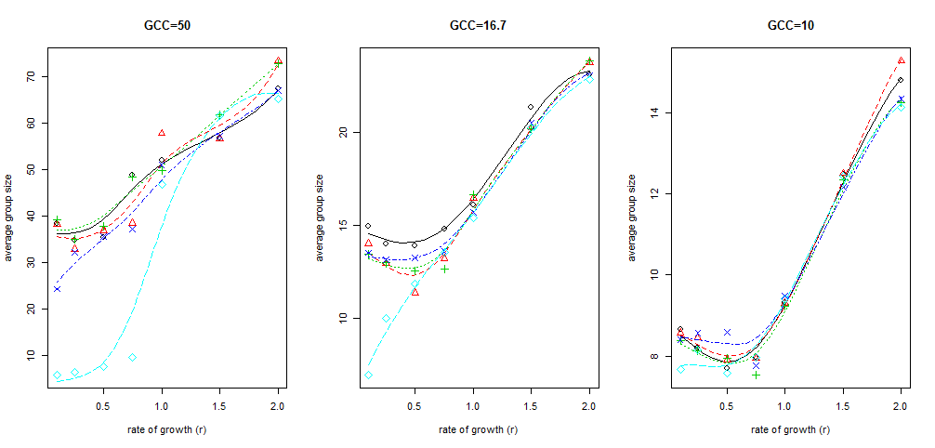

*White noise test and within run correlations*

During each run each output parameter oscillates (figure 2). However significant values of the Fisher's κ statistic carried out on a randomly chosen runs, allow us to reject the null hypothesis that the fluctuations observed in the series are due to white noise (table y).

|  |  |  |
| --- | --- | --- |
| **Parameter** | **Fisher’s κ** | **P value** |
| Average cooperation | 672.3 | <<0.001 |
| Average group size | 1380.3 | <<0.001 |
| Relatedness | 730.1 | <<0.001 |
| Kin preference | 1757.4 | <<0.001 |

**Table y:** The Fisher’s κ value and corresponding p value for a randomly choose run.

During the runs the oscillating values of cooperation is correlated with group size and relatedness is correlated with kin preference. Kin preference and relatedness are counter-correlated with cooperation and group size (figure 2). Leticia: I have potentially found a way to test/measure correlations within time series, using a function I found in R. If you agree I think it might be good to test for the amount of correlation within all runs and get the average result, as the magnitude of correlation seems to differ a bit between runs, but not necessarily the direction. (see table z below for an example of cross-correlation tested for one run)

**D:\RFile\Rplot08.tiffFig 2:** Time series showing oscillations for R=0.1, c=0.06, β=0.2. Lines shown are cubic spline fits with flexibility parameter λ= 0.001 on the original data. The first 10000 records of the run were removed to ensure that the cycle had reached equilibrium.

|  |  |  |  |  |
| --- | --- | --- | --- | --- |
|  | Cooperation | Kin Preference | Group size | Relatedness |
| Cooperation | NA |  |  |  |
| Kin Preference | -0.052 # not such a strong correlation | NA |  |  |
| Group size | 0.256 | -0.845 | NA |  |
| Relatedness | -0.185 | 0.646 | -0.862 | NA |

Table z: Cross correlations for sample time series

**Discussion**

**INCLUDE: importance of allowing two traits to evolve together**

It has been demonstrated many times that the evolution of costly altruistic behaviours can be facilitated if social groups restricted themselves to relatives (refs •••) However there must be ecological and demographic factors that can prevent groups from being formed of close relatives. An important, but seldom asked question is therefore under what conditions kin preference traits should evolve and can therefore give us an insight into why the composition of social groups varies across social taxa (Pamilo et al. 1997; Ross 2001; Clutton-Brock 2002; Beckerman et al. 2011). This study shows that the ecology of a species can indeed influence the degree of cooperation that evolves. The main finding from this simulation is that the factor that had the largest effect on the kin cooperation of social groups was intrinsic fecundity of the species. Intriguingly group carrying capacity only had a small influence, except cases where the intrinsic rate of growth was very low and cost of cooperation high.

*Explanation of effects of R, Beta and C*

We have corroborated results for other studies which suggest that there is a trade-off when forming social groups between group size and kin restrictiveness (Avilés et al. 2004; Altmann 1979; Chesser 1998; Lukas et al. 2005) that as the intrinsic rate of growth of a species or population increases so does the level of kin preference that can evolve as more relatives are available. This allows groups the ability to be more restrictive in their admission requirements by admitting only kin. For example EXAMPLES NEEDED Within chimpanzees Lukas et al. (2005) showed that the level of relatedness within individual groups was related to the group size. It must be noted that in this simulation we had represented semelparous species with groups reforming every generation, with species that breed multiple times close kin groups could be formed by internal recruitment (Avilés et al. 2004)

However this only has an effect on the level of cooperation that evolves when the group carrying capacity is large and the cost of cooperation is high, which is reflected in the sizeable contribution interaction effects have in the level of cooperation that evolves . van Veelen et al. (2010) demonstrated analytically using equation (x) that it pays for an individual to cooperate within small groups. However it becomes unfavourable to cooperate if an individual finds itself in a large group. What ‘large’ is depends on the ecological constraints with a species and population, such as the cost of cooperation, group carrying capacity and the average cooperation level within the group an individual finds itself in. As the cost of cooperation and the group carrying capacity increases so what is considered ‘large’ also increases. We could define ‘large’ as the point where an increase an individual’s cooperative tendency decreases its overall fitness. This could be thought of as the law of diminishing returns and a humped shaped function of fitness against group size has been demonstrated many times (e.g. •••) . If the cost of cooperation is high enough and the group carrying capacity so high that having only a few individuals cooperating does not increase an individual’s fitness. For example if there are tasks that cannot be completed without a large number of individuals such as the bark beetle…..This reduces the equilibrium point so low levels of cooperation and low groups sizes evolved.

However when the cost of cooperation is very high this offsets this is as the decrease in the overall fitness to the group by having a low cooperator is offset by the much higher fitness to that low co-operator.

Within our simulation this disadvantage of being in large groups if there is a large cost of cooperation is mitigated if groups admit only kin. Even with high costs of cooperation, if there are enough kin around high levels of cooperation and altruism can evolve.

Examples of organisms where large intrinsic rates of growth allow restrictive kin selection and very large social groups are eusocial insects eg (••••)

Interestingly we show that kin preference does not go to zero, even for very small rates of growth. This may be because leaving relatives out of a group has an indirect fitness cost as these individuals will be eliminated from the population. So this implies that groups forming in nature will not purposefully exclude from social groups (unless there is direct competition) eg •••

It is worth noting that the within our parameter range, the cost of cooperation parameter has little or no effect on any of the variables when the group carrying capacity is small or the intrinsic rate of growth is not very low. This is due to the fact that when there is low group carrying capacity groups are able to admit only kin, keeping the level of cooperation that evolves high despite the cost. There are many example of this in nature such as cooperative breeding birds where individuals forgo breeding opportunities to help relatives breed (e.g. (Hatchwell 2009) and more needed

*Explanations of correlations within runs*

Another interesting result is the periodic cycles that emerge within the runs and the counter –correlations. Obviously relatedness is correlated with kin preference because, as the amount of kin preference exhibited increases so does the levels of relatedness within groups.

Group size is counter-correlated with kin preference and relatedness because as kin preference increases within the runs, entry to groups becomes more restrictive and therefore group sizes decreases. This is contrary to the averages of the runs (figure x) when kin preference increases the group size also increases.

The close correlation between group size and level of cooperation reflects the fact that optimum and stable group sizes are directly proportional to the averagecooperative tendencies in the groups, as seen in eq (3) in Avilés (1999); eqs (4 & 5) in Appendix of Avilés et al. (2004), and Table 1 of Van Veelen et al. (2010).

The counter-correlation between the cooperation/group size and kin preference/relatedness time series may reflect the following series of events: as kin preference, and thus degree of relatedness within groups, increases, greater levels of cooperation evolve, albeit with a certain time lag (in the graphs, we see cooperation raising following a peak of relatedness). Greater levels of cooperation, however, favor the formation of larger groups (since the optimum group size is directly dependent of average cooperative tendencies, gamma/c). The formation of larger groups may require less restrictive admission requirements, thus causing the kin preference rules to bounce back to lower levels. This will in turn lower the degree of relatedness within groups, which would then allow the accumulation of less cooperative cheaters within groups. This may then lead to lower group productivity and thus favour again groups that are more restrictive in their kinship admission rules. This would also explain the cycling that is observed

The above is merely speculative. It would be nice to figure out ways to test these suggestions in the simulations themselves.